Laudato Si- Its Theological, Spiritual and Practical application.
SMA Summer School Dromantine
Booking Form
Please Tick session or sessions you wish to attend
Saturday  25th of June  9.30am | Dr Cathriona Russell TCD  Realities are greater than ideas; Laudato Si and Environmental Ethics. | ☐
Saturday  25th of June  Workshops 11.30am | Padraig Mallon  Laudato Si and Business -Good Corporate Citizenship or Profit-Making Opportunity?  Or  Sr. Mary Kate Hagan RSM  Laudato Si - A new Planetary Vision. | ☐  ☐
Workshops  2.30pm | Prof Eamonn Conway.  Laudato Si - the Biblical and Technological Paradigms.  Or  Dr John Feehan  Creation Walk in Dromantine grounds. | ☐  ☐
Sunday  26th of June  9.45am  11.30am  2.15pm  3.15pm | Fr. Donal Dorr SPS  The Ecology Encyclical of Pope Francis, an inspiring call to contemplation and action.  Contemplative Spirituality  Spirituality in Action  Group Work and Dialogue  Eucharist | ☐
Monday  27th of June  9.30am | Dr Lorna Gold, Trocaire  Laudato Si -A Challenge for Governments and Policy-Makers | ☐
Monday  27th of June  Workshops  11.30am | Catherine Devitt, Jesuit Centre for Faith and Justice  Laudato Si: A Universal Template for Social Transformation.  Or  Sr Catherine Brennan SSL, Eco Congregation Ireland  Laudato Si – Practical Application at Personal, Parish and Community Levels. | ☐  ☐
Monday  27th of June  2.30pm | Dr. Sean McDonagh SSC  Laudato Si - A Prophetic Challenge for the 21st century. | ☐
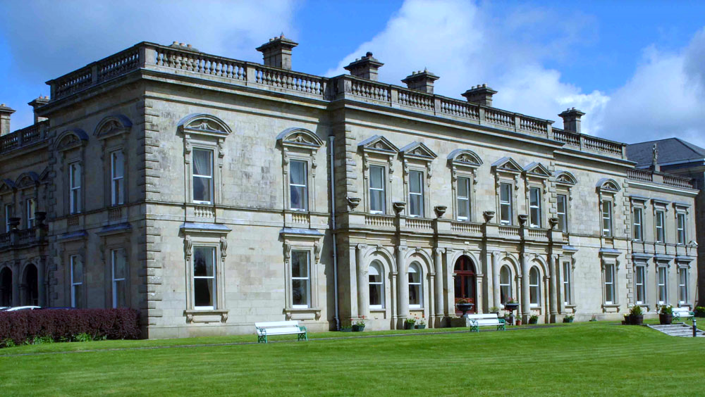  For those attending day sessions | If lunch is required indicate number in box.  Cost is £15.(€20) for each lunch.  B & B plus meals for one day is £60.(€70). | ☐

We would be delighted if you could attend any one or more of the above sessions. Admission is free. For administrative reasons however, we request to be notified in advance if you wish to attend, as space is limited.
If you are attending, please print off this Booking Form, tick the session or sessions you wish to attend, and post the completed form to SMA Summer School, Dromantine, 96 Glen Rd, Newry, Down BT34 1RH or scan and email to: laity@sma.ie
Bookings to be received by10th of June 2016. Any fee for attendance will be collected on arrival. If you wish to stay overnight, there is a concession rate of £60./€70..per day which includes bed and breakfast, meals throughout the day and attendance at the various sessions of the day. Lunch is available at £15 (€20.) but must be indicated when booking. We look forward to seeing you in Dromantine.

